What is high-potency cannabis, and what are the risks to youth?
High-potency cannabis is any product with more than 10% THC.
How much THC is in today’s cannabis?
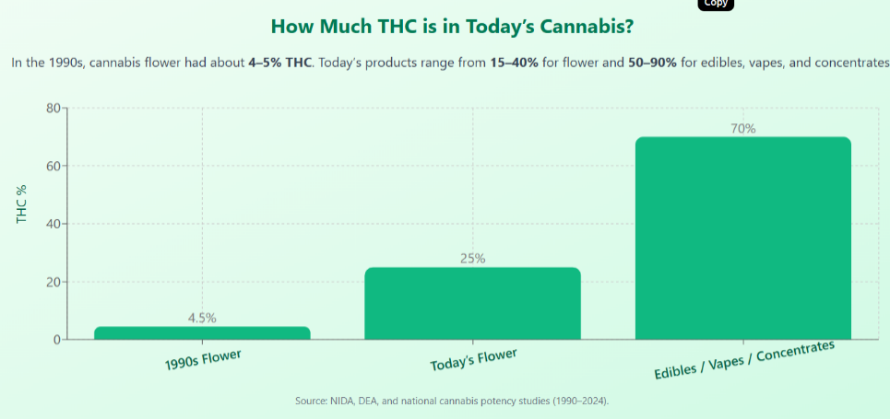
The average THC content in cannabis flower in the 1990’s was around 4-5%, while today, it can range from 15% to 40%. Today’s edibles, vapes, and concentrates can be 50-90% THC.

Teen Cannabis Dependence
Research suggests the higher the potency and earlier a person starts using cannabis, the greater the risk of dependence or addiction. Regular use during adolescence can impact cognitive function and increase the risk of addiction.
Mental Health
The impact of high-potency cannabis on teen mental health is an area of concern; potential impacts include impaired cognitive function, and increased risk of developing psychiatric disorders, including anxiety, depression, and psychosis.
Accidental Poisonings
Missouri Poison Center has seen a steady increase of calls related to children 0-5 years consuming cannabis. Data shows the total number of calls is nearly 30 times higher than in 2018.

For your PSA, choose a fact to state (colored sentences are suggestions) and add a tagline (some ideas are in quotes). These are just ideas, please be creative and make your own if you like!
THC content in cannabis flower was around 4-5% in the 90’s, while today, it can range from 15% to 40%, with edibles, vapes, and concentrates from 50-90%!
“Today’s weed is stronger — keep it on lock!”
“THC’s higher than ever — keep it out of kids’ reach!”
“Protect little hands — lock up your cannabis.”
“Modern cannabis is no joke. Lock it before they find it.
Missouri Poison Center has seen a steady increase of calls related to children 0-5 years consuming cannabis. Data shows the total number of calls is nearly 30 times higher than in 2018.
“Parents, don’t let your stash turn into their snack.”
“Kids see candy — not cannabis. Lock it up.”
“Your edibles look fun — until your toddler finds them.”
“Looks like gummies. Acts like poison. Keep it on lock!”
“Don’t make your kid the next call to Poison Control.”
“High potency. High responsibility.”
Research suggests the higher the potency and the earlier a person starts using cannabis, the greater the risk of dependence or addiction. Regular use during adolescence can impact cognitive function and increase the risk of addiction.
The potential impacts of high-potency cannabis on teen mental health include impaired cognitive function, and increased risk of developing psychiatric disorders, including anxiety, depression, and psychosis.
“Today’s cannabis hits harder — protect their brains. Keep it on lock.”
“Strong weed. Growing brains. Bad combo. Lock it up.”
“Keep it out of reach — protect their mind, their mood, their future.”
“High THC, high risk — especially for teens. Keep it on lock.”
“High potency = high risk for anxiety and depression.”
“Their brain’s still growing — don’t let cannabis slow it down.”
“Addiction starts younger than you think — keep it out of reach.”
“One high can lead to a hard habit — lock it up.”
“Brains still building can build dependence fast.”
“Early use, stronger weed — greater risk of addiction.”

